**Mohammed Mahin Ibnay Mamun - 346584**

**Task 3 – Portfolio**

**This word document contains 2 platforms (tiktok and Facebook) The first half of this document page 1 – 18 is all tiktok and pages 18+ is Facebook.**

***Introduction***

In this document, I will walk you through my trainer company social media page. I will do this by referring to and following my action plan which I made in my previous task. In this document I will show you how I made this social media account I will show you my progress throughout the 2 weeks. I will also show you how I reach out to influencers and how I find key words and trending hashtags. I will clearly label each step throughout, and I will label each heading with a title to make it easier for you to understand. You will see how my company **‘Mz_Trainers’** meets my previous set goals and targets.

**Creating the webpage**

My first task in my action plan is to make an online store. If I do not have an online store, then my customers will not be able to place through their orders. I did not want to spend too long on this because I knew if I took too long, I would be behind on other tasks. To make a webpage quickly I will have to use a previous template or a website builder. I can either use Wix or shopify to create the website. Due to previous experience, I will be using shopify to make my website because I have used it before so it should be too hard. Once I have personalized the website, I will need a domain. A domain is used on websites/webpages to make your website more specific and easier to spot compared to others. Domains have a charge on them, but most are less than £10 so it is not too expensive. For this example, I will just use a cheap one which will only cost me about £1. I can find these available on the internet on sites such as Eg: GoDaddy, webador, Alibaba ECT. Once I create the website, I will show you some screenshots of what it looks like. I managed to get myself a domain (Mz_trainers.com) <-- you can see this at the top of the screenshot below. The domain is on the hyperlink.

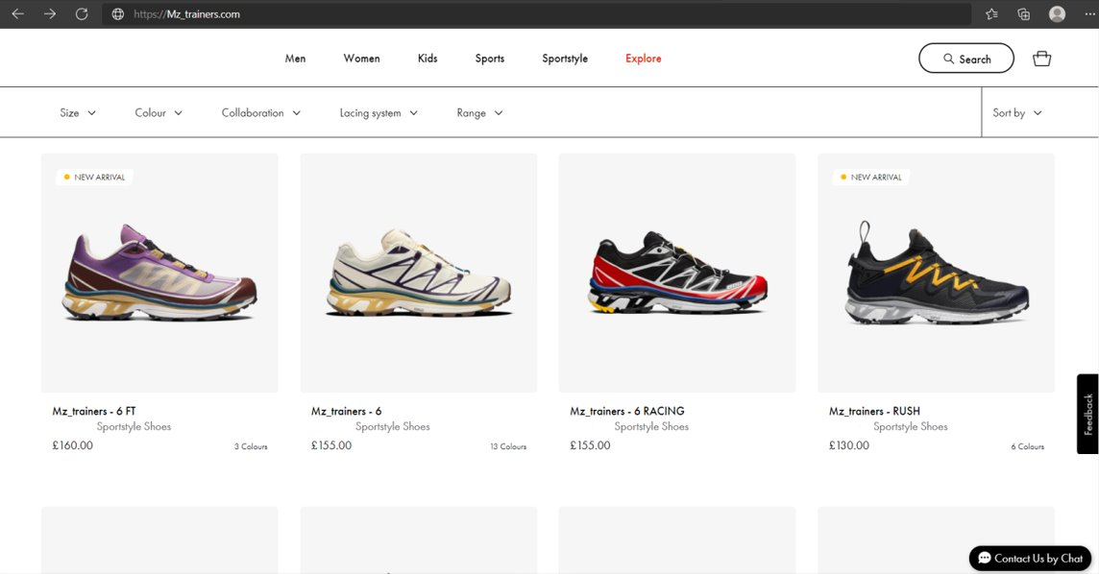

**Creating and customizing social media accounts**

For my trainer's company, I chose two platforms of social media which I want to use to promote my product. I chose to use tiktok and Facebook. The main reason I choose to use these 2 specific platforms is because they are both particularly good when promoting.

* **TikTok**

I am using tiktok as one of my social media platforms because I know a lot of people use it. In January 2021, tiktok had 689 million. Another reason I am using tiktok is because you can use hashtags and get your video on the for you page meaning your content will be viral.

**CREATING THE ACCOUNT**

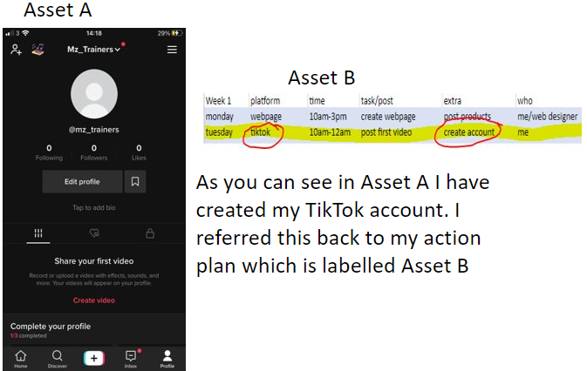

In the screenshot provided above, you can see that I created a new tiktok account and named it with my company ‘Mz_Trainers’ the reason I made it is because it is my next task on my action plan. To keep this project professional, I must follow my action plan. This will give me a good guide to proceed.

**Bio**

Having a Bio allows you to highlight the major aspects of your business to your customers. Your bio is shown on your profile and can be viewed by anyone. An individual's bio gives people an idea of who they are and what they do. In my bio, I have added a catchphrase to draw attention. I also added 2 aspects of my trainers.

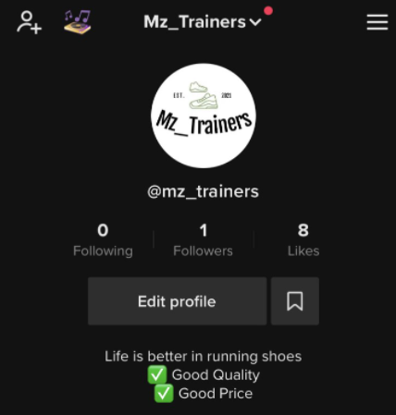

**Logo / profile image**

I will also create my own logo for my tiktok profile picture. To make this logo I am going to use an online logo maker. The reason I will do this is so I have a template which I can render too. Using a template would speed up the process. For example, I used this template online and then I rendered it and made my own. Shown below is the template and then my logo.



I will use this logo as my profile picture on my social media account and I will use it on my webpage. On the tiktok page the logo looks like this.

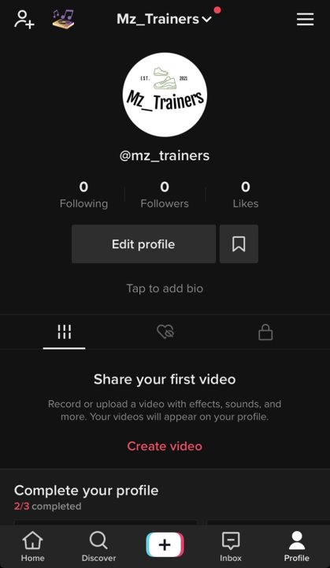

As shown above in the screenshot you can see I have used the logo as my profile picture. Using a logo is a way of showing identification. It also looks more professional to my customers. A customer is more likely to buy from a company with a logo compared to one without, this is because having no logo can look like a fake account or a fraud.

**First post and analytics**

I will now post a video. Posting a video will allow me to enable analytics which are especially important. Having enabled analytics, I will have access to making my account either a business account or a creator account.

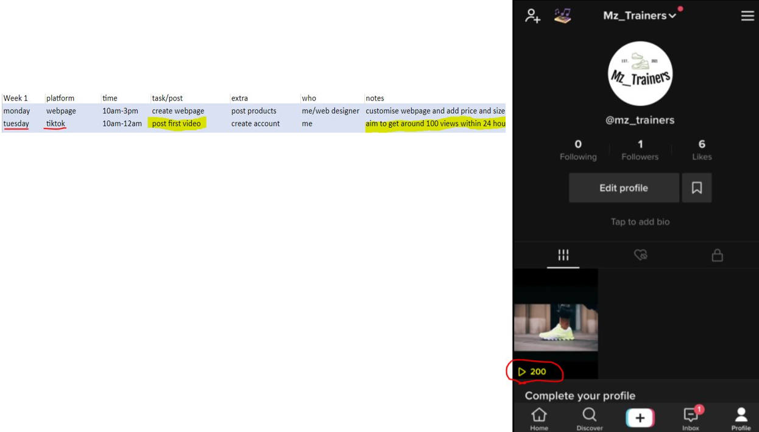

As you can see from the image above, I have achieved my task of the day by posting a video. And I also managed to complete my note goal of aiming to reach 100 views. 24 hours after posting this video, I managed to get 1 follower, 6 likes and 200 views. Now that I have posted a video, I can successfully unlock the tiktok analytics.

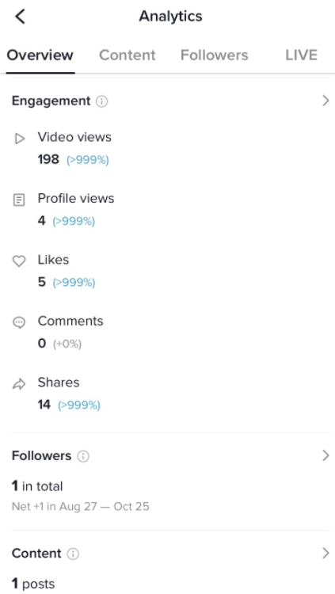

Here is an overview of my analytics from the first 24 hours. This page allows me to check my views, profile visits, likes, comments and shares. It also shows how many followers I managed to get.

**SWITCHING TO BUSINESS ACCOUNT/Category**

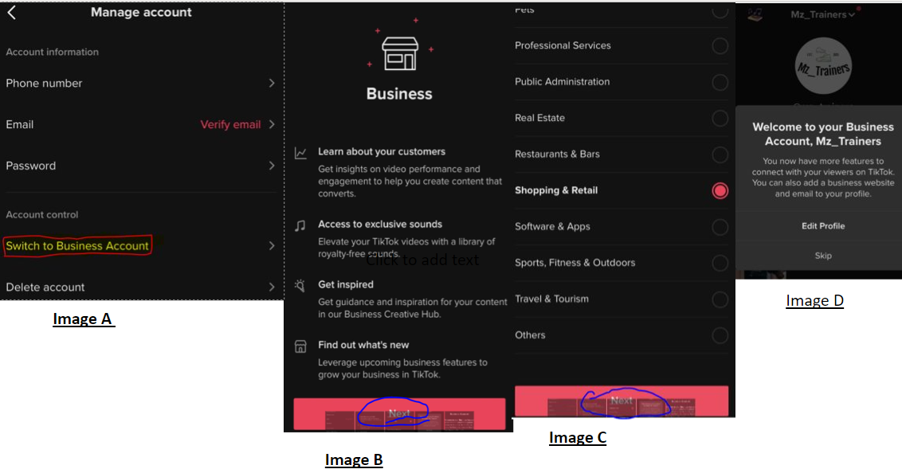

I took screenshots through this and uploaded them in the screenshot above. I have labelled 4 screenshots with letters a-d. This will make it easy for me to explain what is happening in each step.

* **Image A:** to get to that page I simply had to click on the edit profile icon which is visible to account owners. Once I entered the edit profile page, I clicked on switch to business account. In the screenshot I have Cleary highlight this and outlined it for you to see.
* **Image B:** After completing the previous steps explained in image A, I was redirected to this page. On this page it explains to you what business accounts are and what features they have. For example, you can learn about your customers, find out new features and access exclusive sounds. After reading this page, I click on the next at the bottom of the page to proceed.
* **Image C:** **Category:** once I have clicked next in image B, I can now choose a category which best matches my business. Because my tiktok page is based on selling trainers, shopping and retail was my best match. Unfortunately, on tiktok you can only choose one category. After making my choice I decided to proceed to the final stage.
* **Image D:** At this stage I have successfully made my account a business account.

**TRENDING HASHTAGS**

To get more views on tiktok and make your video go viral you must use hashtags. Using hashtags gets your post more recognition and makes it easier for people to find. When users on tiktok are looking for a certain type of video, they use find these through hashtags. Once they click the hashtag, they see a screen with lots of posts all targeted at the searched hashtag. If the users search match is involved in your post, then they will view your post. Below is an example of this.

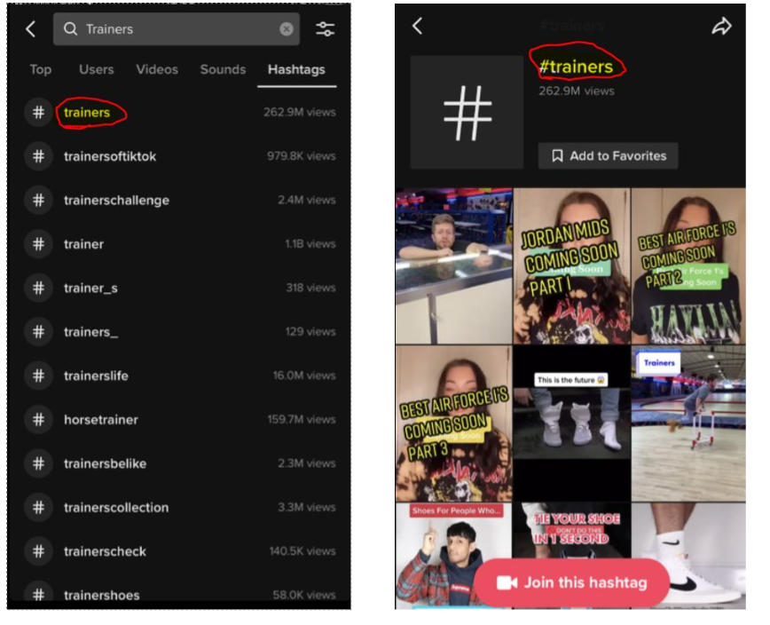

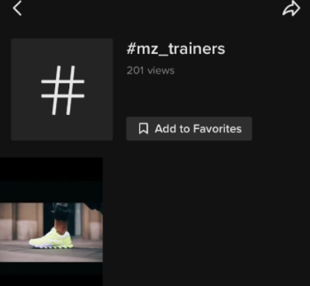

Here is an example of mine. If any user decides to type in mz_trainers in the search bar they will see this page.

So, when it comes to posting you should always look at the hashtags which are being used most of today. Each day there will be an update on this. However, you can still use it anyway if you think it works well with your video. For example, I decided to create another post. I chose to do this to follow my action plan. When I created the video, I then clicked on #hashtags and as you can see in the image below, it recommended me with 2 hashtags and shows besides it the number of views they reached. The number of views reached is the number of viewers who searched up that hashtag. This refreshes every day and tiktok always gives you better hashtags to match your video.

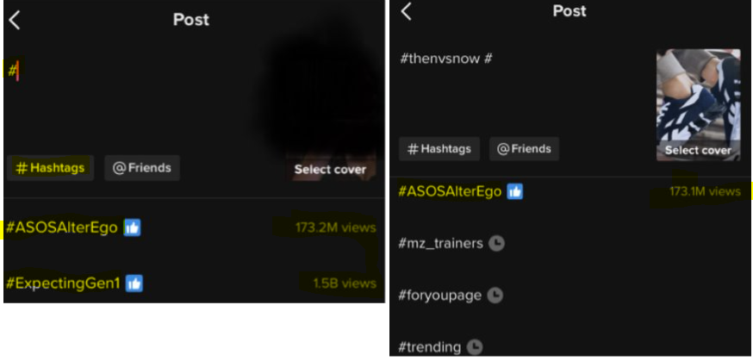

This part was also on my action plan. Using hashtags was on my extra and my main goal was to post another tiktok today. I also wanted to aim to reach around 25 followers. This is all on my action plan which I will show you now.

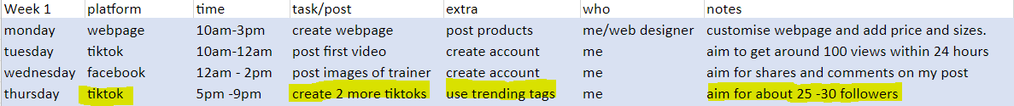

Now I will show you that I have completed my task of posting 2 tiktoks, and I will also see if I managed to reach my note of 25 followers.

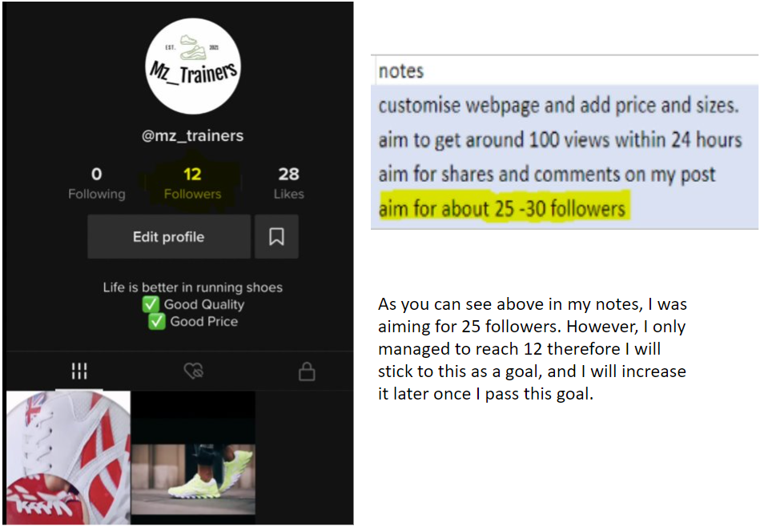

**Discount code**

It is currently week 2 on the tiktok project and today I will create a post with a discount code. I will also make this code valid on the webpage for customers. This code will give them a discount on the product they choose to buy. Customers use discount codes to redeem deals.it is also proven that providing discounts and offers make your customers happy.

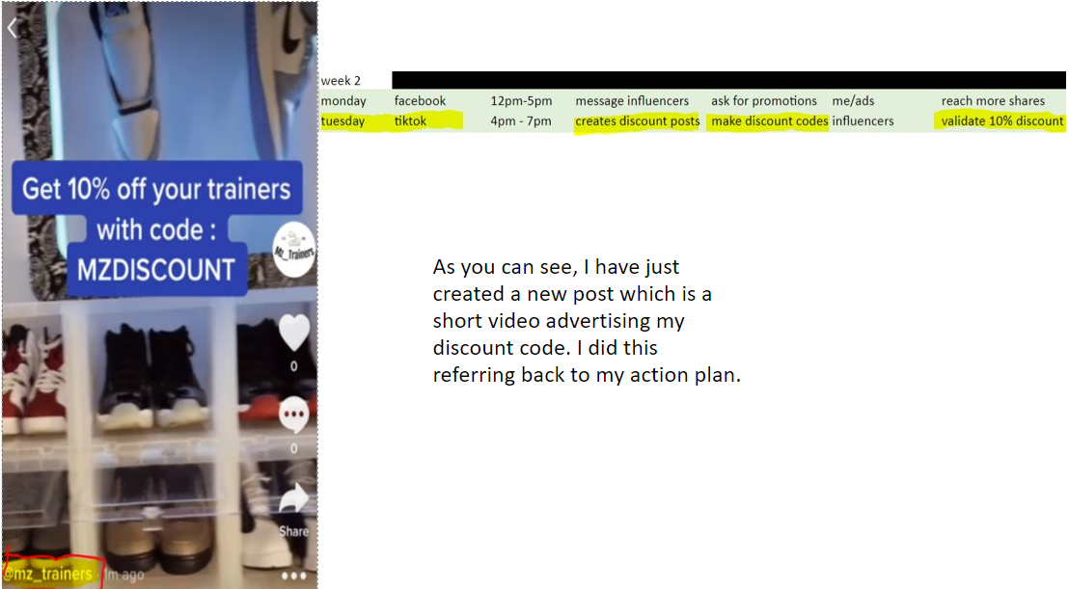

**CONTACT INFORMATION**

For my customers to be able to communicate with me or my online store, I will need to provide some sort of information. One way I will do this is by adding my email address. Providing my email address gives my audience access to email me any of their enquiries. Or the customers can leave a message on my post, and I will be replying to them all. I will now update these and show you a screenshot.

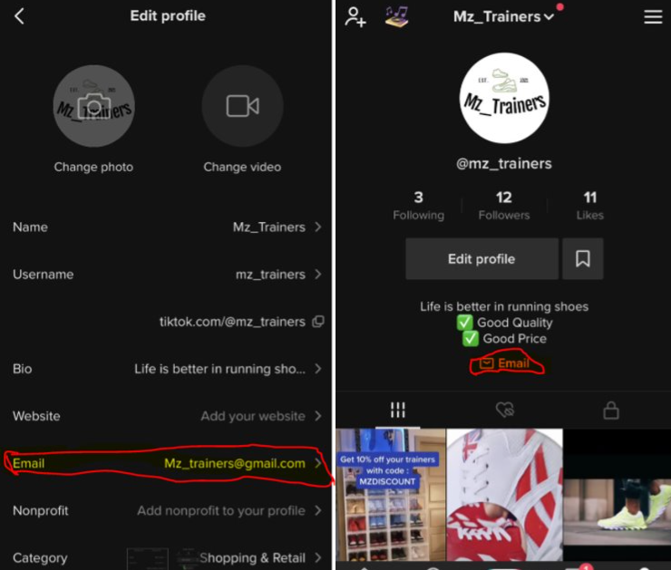

I have clearly shown you that I have added an email address where the users can reach out to me if they have any questions or problems regarding my business.

**ADDING A WEBSITE**

At the beginning of this project, I created my website. I will now link this website to my tiktok account. The way I will do this is by clicking edit profile on my tiktok account page and then I will paste the hyperlink from my website into the website bar.

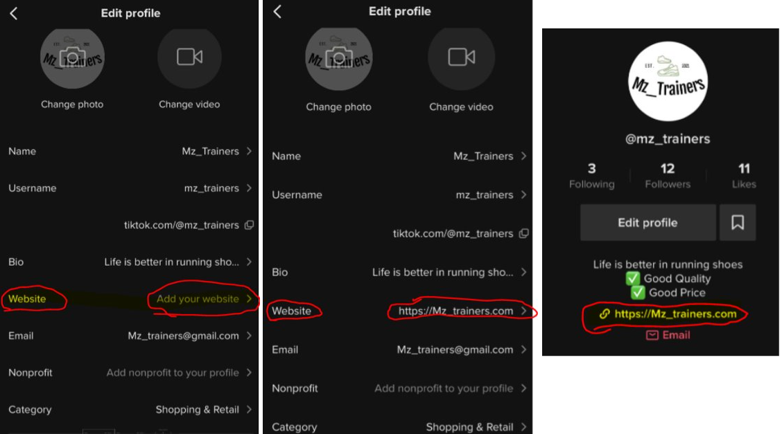

Now that I have included a website, when any tiktok user goes to my profile and clicks the link they will automatically be redirected to my website where they can buy my products.

**REPLYING TO MY COMMENTS**

Closing off this project, I have one last task left to do. Within these last 24 hours, I need to complete my final goal on tiktok which is replying to comments and messaging followers. 

The way I would do this is by checking each of my videos first to see if I received any comments. If I have then I will reply to them. Once I have replied to all comments on my first post, I will do the second post then my final post. After that, I will start messaging some of my followers asking them if they are interested in buying my product and hope to see a reply.

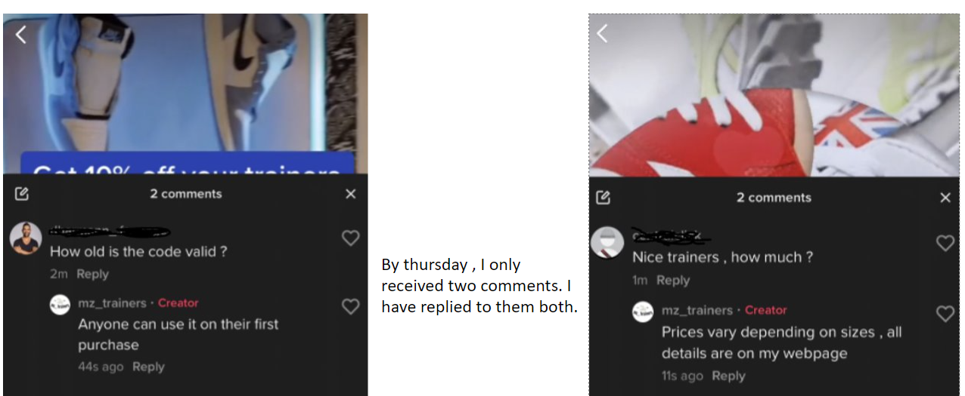

Now that I have replied to both comments, I can now start messaging my followers. I will simply ask them politely to check out my webpage. This leads them to go to my store online and if they like the products they may buy some trainers.

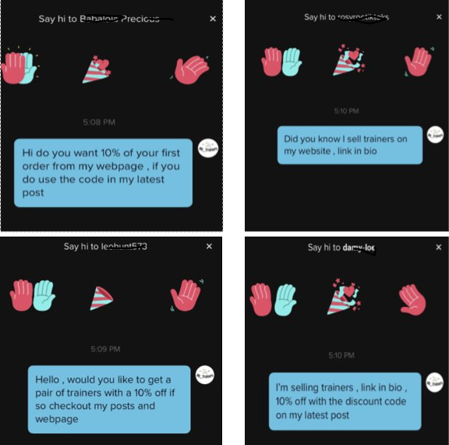

**END USER VIEW OF ACCOUNT**

The end user view will be the same for everyone except myself. This means that every single tiktok user who clicks on my profile will all see the same page. The page they will see will look like this:

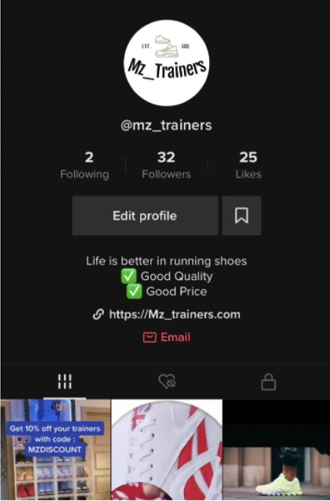

**FINAL ANALYTICS**

My final goal is to check my overall progress. I would do this to see if I managed to succeed and reach my previous goals. I will check my tiktok analytics now to see how much I have managed to progress in my first week of creating this account.

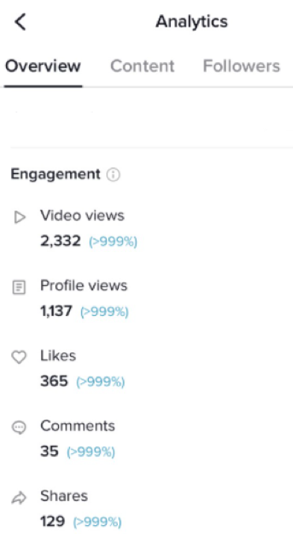

The image above here shows me my overall results on my account. I think I did quite well by looking at these numbers. I was not expecting to reach this amount. At the beginning I only had 2 comments, now I have 35. I also remember having 14 shares and now it has drastically increased by 100. I knew that I would get quite a lot of views, but I did not think I would reach more than 1000 however I have.



-----------------------------------------------------------------------------------------------------------------------------------------

**FACEBOOK**

I have chosen Facebook as my second social media platform. A quick brief of why I choose to use Facebook for promoting my product is because Facebook is good at it. By that I mean Facebook is good at promoting your products. One way I can do this is by creating a group where I will tell people about it and ask them to buy it or share it on their page. Sharing this around will cause more audience which is better from my business because having a larger audience means I will be able to get a higher chance of sales.

**Creating a social media account**

To create the Facebook page, all I will need is to provide my name, email address or phone number verification and a password. These are simple and should not take too long to create. Once I create the account, I will add the same logo which I am using in my other social media account (TikTok).

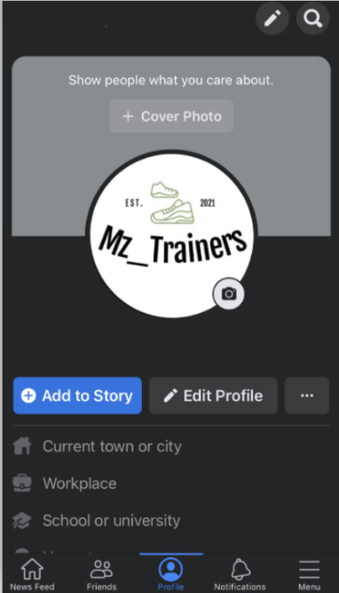

**BIO/ account customization**

For the Facebook account, I can add a bio. This can easily be done just by clicking on the edit profile icon and bio. As I have already created a bio for my tiktok page, I might just use the same one or I may add to it. I will once again, like before, provide a screenshot of this below for you to see. Aswell as adding a bio, I will add some of the personal details, so my page looks better and does not look blank.

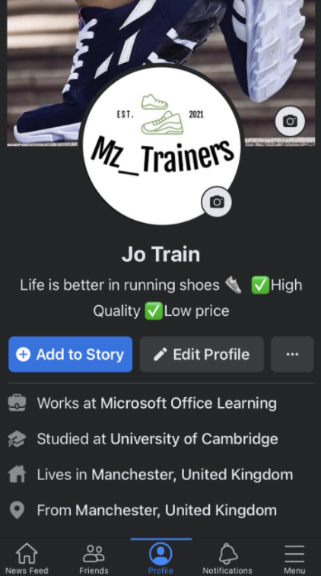

**First post**



Written in my action plan, I set today's task to post the first image of the trainers which I am selling. I also set an additional goal of creating the account which I already have done. Now I just need to create a post. As a note to myself, I have set a small goal which I aim to achieve before my next task. For this one, I am setting it at aiming for a comment or a share.

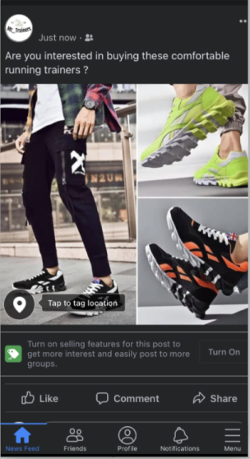

Here is a screenshot of my first post. I added a caption at the top which might interest some of the audience. This is the first part of my Facebook task. I will now move on to the next section and show you screenshots throughout. We will come back to the post at the end of the project.

**Creating Facebook Group**



For my next goal I need to create a group. Within this group, I will be the administrator and only I can add posts and send messages to the group. Anyone who decides to join this group will be a member and they will have much-limited access compared to me. As a member of the group, you will be able to view and read everything, however you do not have access to posting. If I choose to team up with someone else, then I can give them permission and make them co-administer or an owner of the group like me.

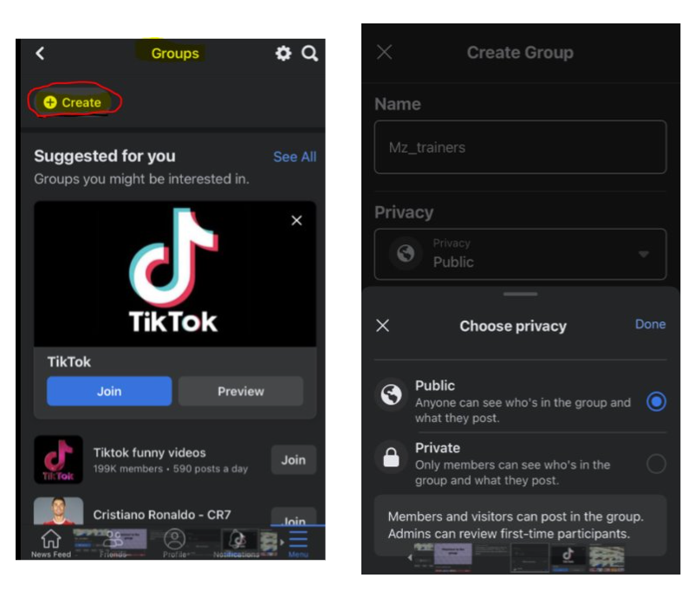

Creating the group was not too hard. I just had to click on the groups icon and then create. Once I clicked on create shown in the image above, I then got redirected to another page which asked me to create a group name and a privacy of the group. I had a choice either private or public. I have chosen to make the group public. The reason for this is because now anyone can see what I post, and they can join. I think if people saw my content, they would join whereas if my group were private, they would not have joined.

**Customizing the group**

Continuing from before, after I had chosen to make my group public, I had to design my page for my group. This did not take too long either and I found it quite simple. Here is what I had to do:

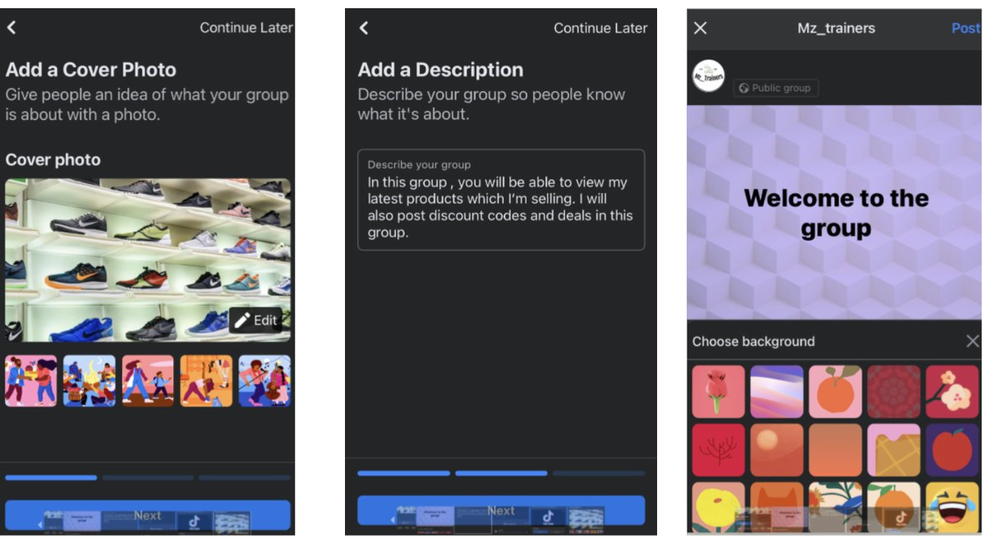

The first step was to add a cover photo. Facebook had a few animated covers, but I did not want to use them because they did not match my overall theme. So, I decided to use one of my own photos of my trainer collection as my cover photo. After this I moved onto set 2. At step 2, I was asked to add a description of my group. In here I mentioned how I will be posting Images of my product and I also added to the description that I will be adding discount codes and coupons in this group. I did this because it is a successful way to attract a larger audience. The decisive step was to create a post for the group. Because it is my first post, I have chosen to post a welcome.

**Reaching out to influencers**



As part of this task, in week 2 I have set myself the goal of finding influencers. Once I find these influencers who I think would be able to help me gain more customers, I will ask them to share my post or group. By doing this, I will get more customers overall. In return I will also give them higher discounts on my product. I will look for someone who has a lot of friends on Facebook. This way it is more successful compared to someone who has only one or two friends on this platform. As a reward I will be giving them a sample of my product or a discount.

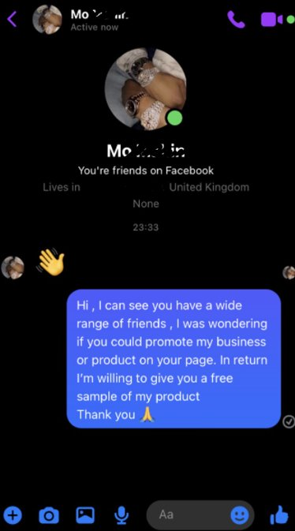

After a while of searching, I finally found a user who was promoting a lot of other users posts on his account. I kindly asked if he could advertise mine on his account. I am currently waiting for a reply. Once he replies, I will introduce him to my group and ask if he will not mind sharing it. Finding an influencer was my task for the day and I have successfully managed to do it. Now I am going to wait for him to reply. In the mean while I am going to move on to my next target on my action plan.

----------------------------------------------------------------------------------------------

**OVERALL STRENGTHS AND WEAKNESSES**

**Strengths:**

* **I managed to keep this task in order by following my action plan and showing evidence of this.**
* **I managed to create both accounts (TIKTOK / FACEBOOK)**
* **Create my own logo**
* **Found hashtags which were trending**
* **Using tiktok to post (have experience how it works)**
* **Find a product which has not been listed on the market**
* **Managed to get some followers and views**
* **I was able to reach my target audience**

**Weakness:**

* **RAN OUT OF TIME. I was so close to finishing that I had 2 tasks left to do.**
* **Finding a product. This took a lot longer than expected**
* **Finding a name for the product/brand**
* **Creating the Facebook page (my first-time using Facebook)**

**Overall, I learnt new skills and I spotted my strengths and weaknesses.**